Literature Review
Alec Hoyland
November 1, 2017

Complications Applying Network Theory to Neuroscience
Twentieth century classical mechanics is sufficient to describe the dynamics of a system and the mechanisms which underlie that behavior. This methodology consists of experimental and mathematical analysis and theoretical modeling of physical systems. Analysis permits a physical scientist to make measurements and fit these measurements to mathematical rules, providing a metric for how systems might behave in the future. Conversely, modeling begins from first principles, establishing and testing a hypothetical set of rules for a system. Good models provide suggestions for experiments which can verify results and provide causal indications between observable, experimental result, and underlying mechanisms.

Similarly, the physics of macroscropic, terrestrial systems is sufficiently advanced to permit a physical scientist to readily predict the behavior of a system of arbitrary structure. A model can predict the structure of a system from arbitrary behavior. Current research at the human-scale is therefore concerned with very complex networks which produce emergent behavior.

The mathematical description of a network begins with a graph, a collection of nodes (vertices) with connections (edges) between them. An edge can be unidirectional (directed) or bidirectional (undirected). In addition, a given edge may have a strength of connection (weight) associated with it. For networks with simple nodes, behavior of a dynamical system on a network of arbitrary topological complexity can be readily computed, though no universal mathematical framework exists for reducing or unfolding these networks.

There exists a well-defined limit for the amount of information a network can hold, the Bekenstein bound (Hod 2015), and the rate of processing information, the Bremermann limit (Gorelik 2002). These limits coincide in a black hole, not within the ken of biological systems. For terrestrial systems, evolutionary principles revalue the problem, prizing robustness and plasticity over capacity and efficiency (Loeb 2012). This is partly an evolutionary consideration but also one of function. A neuronal circuit must be able to process information and produce a suitable “good enough” response.

In the case of the nervous system, the smallest discrete nodes are single neurons. While information-theoretic methods have been applied to networks in the nervous system (Stemmler and Koch 1999; Dimitrov, Lazar, and Victor 2011), these networks are often vast and nodes are abstracted to brain regions, rather than incorporating the biophysical reality of neurons. This is due to several problems with applying network theory to realistic neuronal circuits.

First, neuronal networks are structurally complex. A small network with simple oscillatory dynamics, such as linear rate models or analytically-solvable Kuramoto oscillators, can be readily analyzed (Medvedev 2014); however, a real cortical neuron may have up to 10,000 synapses (Dayan and Abbott 2001). Second, each node is complex. Physiologically-realistic models of neuronal activity are high-dimensional nonlinear dynamical systems (Harris-Warrick et al. 1992), preventing most graph-theoretic reductions of the network topology. Third, nearly all computational characteristics of a neuronal network change over time. Protein turnover and synaptic potentiation contribute to the already variegated diversity of neuronal networks.

Neuronal networks exhibit all of the properties expected of complex graphs and yet act on a wide range of timescales. Electrotonus acts in the fast kinetics of action potentials and the slow kinetics which underly bursting, excitability, and spike propagation. Additionally, the properties which underlie information processing also evolve on ultra-slow time-scales of protein turnover, mRNA regulation, and homeostatic control. While detailed investigation of the morphology and excitability of individual neurons has been thoroughly studied, this has not substantially contributed to a comprehensive understanding of large neuronal networks (e.g. the brain) (Kandel 2013) because it is poorly understood how neurons in networks of that scale (1010 nodes) interact. For this reason, the examination of high-dimensional small-circuit neuronal networks is crucial to furthering an understanding of the brain.

Neurocomputation
The most relevant neurocomputational properties of a neuronal network include the conductances of each neuron, the geometrical structure of the network and the synaptic connections between the neurons.

Neuroscientists have long relied on whole-cell voltage clamp and current clamp recordings, which reveal real-time traces of voltage and temporal dynamics of many ion channel types (Hille 2001). The excitability of a neuron arises from the combination of ion channels within the cell membrane and the maximal conductance of a current type is a function of the number of channels (channel density) and the individual efficiency of the channels.

Since the modulation of individual conductances can strongly affect both the passive and active electrical properties of excitable membranes, maintenance of proper conductance densities is crucial for effective neuronal activity (Kaczmarek and Levitan 1987; Rinzel 1987; J. P. Golowasch 1991; Guckenheimer, Gueron, and Harris-Warrick 1993). The excitability and firing properties of a single neuron is a function of its passive electrical properties, intrinsic currents, and inputs and is sensitive to small changes in conductance density (Rinzel 1987; J. P. Golowasch 1991; Lockery and Spitzer 1992; Guckenheimer, Gueron, and Harris-Warrick 1993). For a network, neuronal properties and synaptic properties must be tuned within characteristic ranges with respect to network output. Depending on the composition and function of the network, specific properties can be variably important to the stability of the network activity (Edelman and Gally 2001, 200; Tononi, Sporns, and Edelman 1999).

The morphological structure and biochemical composition of the cell describes how the signal propagates. Voltage drop over distance can be computed using cable theory, in which voltage signals decay through a leaky membrane as a wavefunction. Some neurons rely heavily on morphological tuning to process information (Mainen and Sejnowski 1996; Stiefel and Sejnowski 2007; Cuntz et al. 2010).

The Stomatogastric Ganglion: A Model System for Small Circuit Dynamics
The stomatogastric nervous system (STNS) provides an excellent model system for analyzing how circuit dynamics arise from neuronal properties and network connectivity. Initial work began in the 1970s (Maynard 1972) using the STNS as a model system to understand central pattern generation. Indeed, several properties make this system ideal for electrophysiological and computational analysis.

The STNS consists of a group of four linked ganglia: the paired commissural ganglia (CoG), the oesophageal ganglion (OG), and the stomatogastric ganglion (STG). Each of the CoGs contains approximately 400 neurons and the OG contains approximately 18 neurons. The stomatogastric ganglion (STG) is comprised of approximately 30 neurons – the exact number varies between species and between animals. Most STG neurons fire tonically when pharmacologically isolated but can be induced to burst conditionally under the influence of neuromodulators or graded inhibitory input (Harris-Warrick et al. 1992). When the STNS is dissected, it continues to produce fictive motor patterns in-vitro which resemble those in-vivo (Harris-Warrick et al. 1992; Kandel 2013; Michael P. Nusbaum and Beenhakker 2002; Selverston and Moulins 1987).

Most synaptic connections in the stomatogastric ganglion (STG) occur between motor neurons, so that the circuit can be isolated from descending interneurons. The fictive motor patterns produced by the STG in-vitro are representative of both the activity of the circuit feedback and the motor output (E. Marder and Calabrese 1996).

STG neurons have a large soma (typically 50-100 micrometers across) and complex branching morphologies. While these cells possess long axons which contribute to descending nerves, much of the arborizations consist of neurites which tangle extensively in the neuropil. This inefficient wiring follows a space-filling mechanism which results in isopotential membranes (Otopalik et al. 2017). Thus, the complexity of the circuit is contained within the intrinsic and synaptic currents instead of the morphology.

STG neurons can be readily examined with electrophysiological methods. It is possible to simultaneously record from 4 intracellular electrodes and 8-12 extracellular nerve electrodes. This robustness to mechanical insult permits hand-dissection of individual neurons for biochemical characterization and electrophysiological recording for at least 24 hours without incubation (Eve Marder and Bucher 2007; Mizrahi et al. 2001). In addition, intracellular recordings can unambiguously determine cell type between preparations and discriminate between large-amplitude synaptic potentials and subthreshold oscillations (Eve Marder and Bucher 2001; E. Marder and Calabrese 1996).

The Pyloric Rhythm
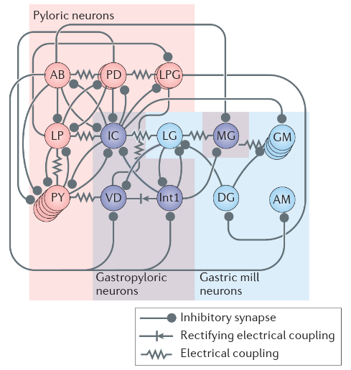
The pyloric rhythm is a triphasic motor pattern almost always continuously expressed in the healthy crustacean (Clemens et al. 1998; Rezer and Moulins 1983). The frequency and intensity of the rhythmic behavior may vary, but the burst order and duty cycle are maintained in healthy animals (Eve Marder and Bucher 2001). The canonical pyloric rhythm consists of bursts of action potentials in the pyloric dilator (PD) neurons, followed by bursts in the lateral pyloric (LP) neuron, and finally by bursts in the pyloric (PY) neurons. The inferior cardiac (IC) neuron fires often with the LP neuron and the ventricular dilator (VD) neuron fires frequently with the PY neurons. The anterior burster (AB) interneuron projects through the stomatogastric nerve to the CoGs and is electrically coupled to the twin PD neurons (Harris-Warrick et al. 1992). The diagram was originally published in (Michael P. Nusbaum, Dawn M. Blitz, and Eve Marder 2017).
Fig. 1. Circuit Diagram of the Stomatogastric Ganglion (Nusbaum and Marder 2017).

The cells of the pyloric circuit are synaptically coupled to each other and receive inputs from the anterior CoGs and OG. If glutamatergic inhibitory synapses are blocked with 10 uM picrotoxin and selective cell-kills by photoinactivation after fluorescent dye injection, the activity of individual cells can be observed (Eisen and Marder 1982; Juurlink et al. 2012). If descending neuromodulatory inputs are also removed via sucrose block, all cells except for AB fire tonically or quiesce. AB maintains burst characteristics (Selverston and Moulins 1987; Scott L. Hooper 1997; Harris-Warrick et al. 1992).

In normal pyloric activity, the AB neuron intriniscally oscillates. The PD neurons, electrically coupled to AB, burst in phase. The AB and PD cells inhibit LP and PY, which both burst during PD interphase. LP rebounds from inhbition faster than PY and bursts first. LP and PY are in a half-center oscillator regime of mutual inhibition, so PY neurons rebound and terminate the LP burst. In this regime, AB is considered the intrinsic pacemaker and AB-PD the pacemaker kernel. The phaselocking of LP and PY during PD interphase is dependent on the intrinsic and synaptic characteristics of the network (S. L. Hooper and Marder 1987; Hartline 1979).

The pyloric rhythm is very robust to perturbation. The circuit is most stable under physiological conditions (11 deg. C with descending neuromodulatory input), however the STG can maintain pyloric rhythmicity under threefold temperature perturbation and long-term decentralization (Hamood and Marder 2015; Goldman et al. 2001; Haddad and Marder 2017). Since the STG exhibits degenerate morphology which results in isopotential neurons, the circuit stability must be due to intrinsic or synaptic factors.

Modulation in the Stomatogastric Ganglion (STG)
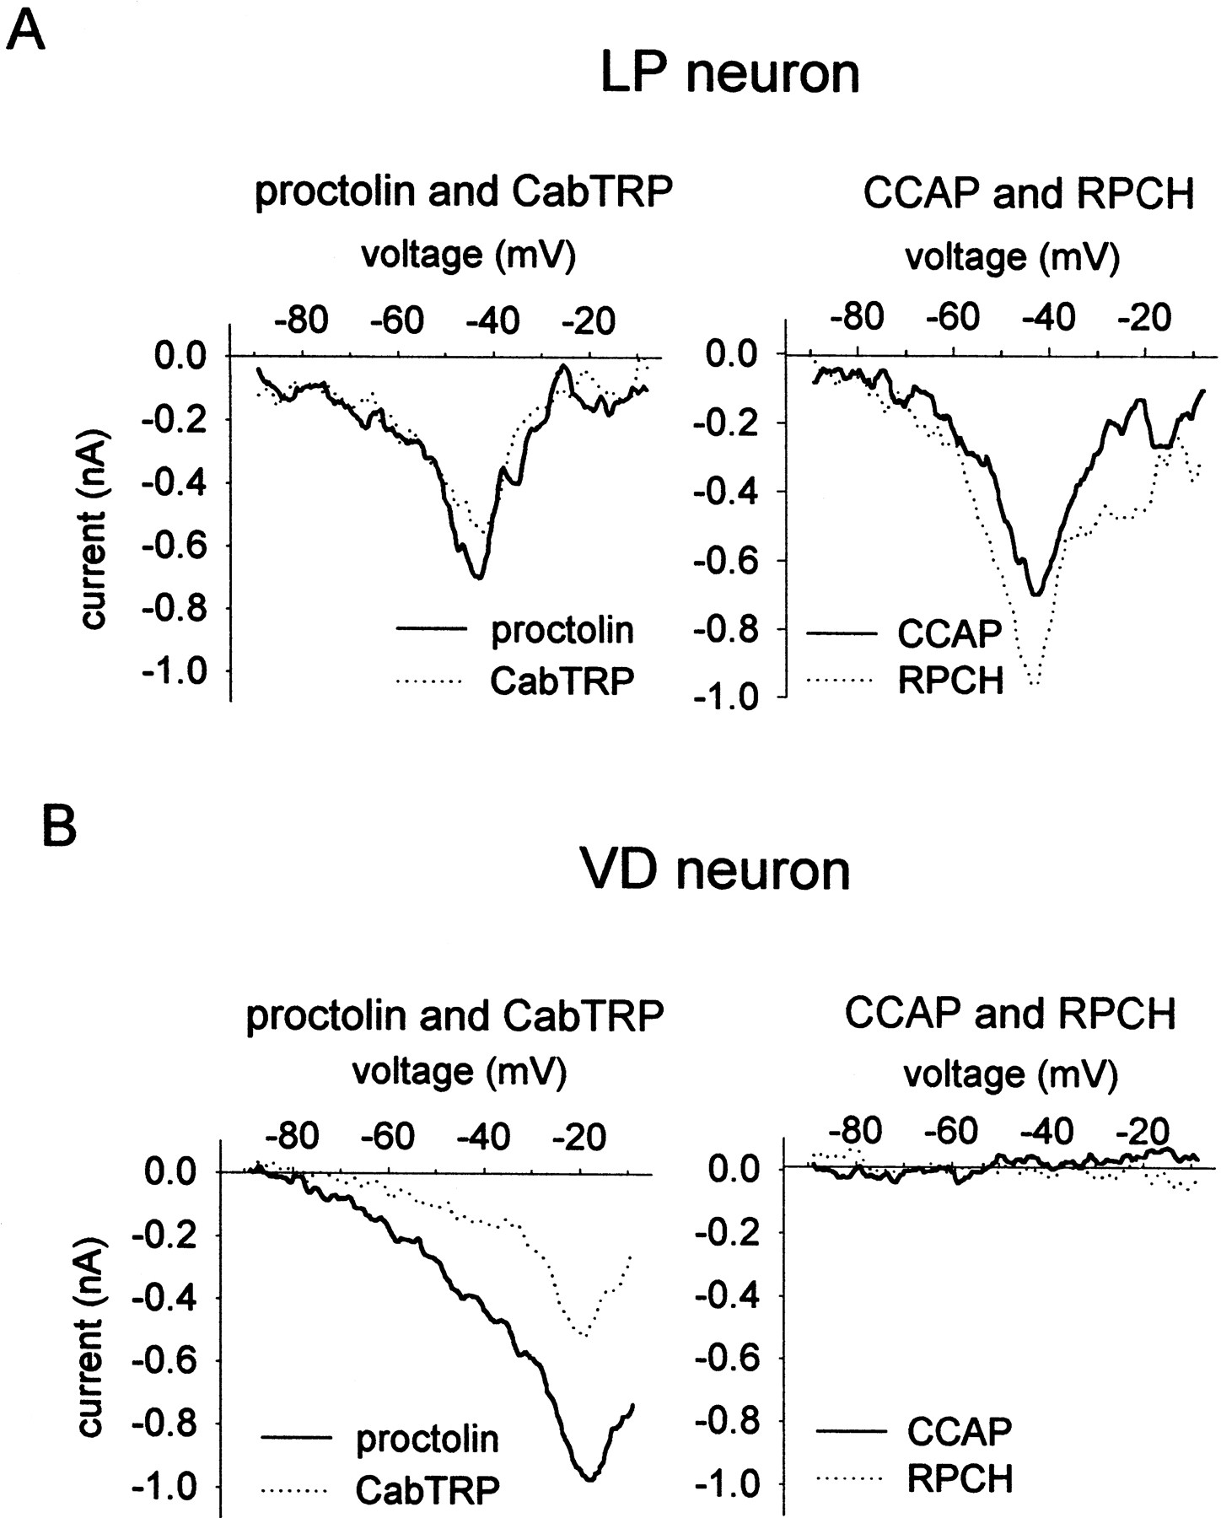
While the pyloric rhythm is highly robust to environmental perturbation, it is also susceptible to neuromodulation, allowing for diverse flexibility in network output while maintaining stability. Neuromodulators are released into the neuropil as a consequence of sensation or descending modulatory projections from the CoG (Eve Marder 2012; Johnson and Harris-Warrick 1997; Michael P. Nusbaum and Beenhakker 2002; Eve Marder and Bucher 2001; M. P. Nusbaum et al. 2001).
Fig. 2. Modulatory input current (Swenson and Marder 2001).
Unlike many other circuits, the STG is multiply-modulated. The pericardial organ and other neurosecretory organs secrete neuromodulators into the neuropil which colocalize in specific neurons (M. P. Nusbaum et al. 2001; Blitz et al. 1999). In addition, many hormones circulating in the hemolymph can also act as neuromodulators in the STG (Harris-Warrick et al. 1992; M. P. Nusbaum et al. 2001).

In the context of this work, the perturbation considered will be neuromodulation, specifically, the activation of, an excitatory modulatory input current. In general, neuromodulators enhance the flexibility of neuronal networks. In one such method, neuromodulators activate a new current (J. Golowasch and Marder 1992a, 1992b).
All cells of the pyloric network are capable of producing , though each cell can vary in its response. Differential receptor expression leads to variability and flexibility in cellular and network response to modulatory chemicals. The effects of neuromodulators can be mimicked in-vitro using dynamic clamp to inject current commensurate to a predetermined current-voltage relation (Sharp et al. 1993; Swensen and Marder 2000, 2001).

Modeling in the Stomatogastric Ganglion (STG)
In 1995, Turrigiano et al. established nine voltage- and time-dependent conductances to simulate conductance-based STG neurons using the Hodgkin-Huxley formalism (Hodgkin and Huxley 1952; Foster, Ungar, and Schwaber 1993; Turrigiano, LeMasson, and Marder 1995). Ionic gating variable curves were fit to IV-curve voltage-clamp data using Newton’s method (polynomial fit). Other experiments used dynamic clamp to test model currents in real neurons (Sharp et al. 1993; Destexhe and Bal 2009). While other conductance-based models in the STG had been developed prior (Abbott and LeMasson 1993; LeMasson, Marder, and Abbott 1993), Turrigiano et al. has been cited frequently in future STG models (Liu et al. 1998; Prinz, Billimoria, and Marder 2003; Prinz, Bucher, and Marder 2004; Prinz 2010; Soofi et al. 2014; Drion et al. 2015). The complete description of major conductances in STG neurons has been built upon, rather than reinvented.

Strogatz explains that, “No insight is gained if the model is as perplexing as the phenomena it is supposed to describe” (Strogatz 2003). To this end, conductance-based models of the STG have strived for verisimilitude only so much as to encompass the burst characteristics, phase relationships, and other neurocomputational properties of the circuit, rather than to mimic the precise waveforms of intracellular recordings. Robustness remains a key feature of the pyloric rhythm.

A single-compartment conductance-based model database demonstrated that diverse sets of maximal conductances can produce spiking activity. Neurons can be approximated as isopotential due to morphological degeneracy (Otopalik et al. 2017). While the set of points in conductance space which elicit spiking behavior is not ergodic, the spiking subspace is much larger than initially expected (Prinz, Billimoria, and Marder 2003; Goldman et al. 2001; Jorge Golowasch et al. 2002). In three-cell networks (ABPD composite, LP, PY), simulations elicited similar network activity from disparate network parameters, showing the theoretical possibility of significant network degeneracy. The intrinsic maximal conductances were plucked from the STG model database, which in turn were based upon the original recordings in Turrigiano et al. These theoretical intuitions were supported by mRNA assays, demonstrating significant animal-to-animal variability (Schulz, Goaillard, and Marder 2006; Goaillard et al. 2009; Bucher, Prinz, and Marder 2005; Hamood and Marder 2015).

Models of network activity in the STG have demonstrates network degeneracy (Prinz, Bucher, and Marder 2004) and pacemaker models have shown robustness to environmental perturbation (Caplan, Williams, and Marder 2014), however no model to-date has demonstrated both robustness and network degeneracy.

While each subfield in biology prefers its own metric for robustness (Stelling et al. 2004), robustness is generally understood to be the insensitivity of some functional system to a set of distinct conditions. For example, triphasic rhythmicity is necessary for innervation of pyloric muscles in crustaceans, so the ability to maintain phase under increasing temperature is a form of robustness (Soofi et al. 2014). In this way, robustness is considered inextricably linked to biological fitness (Kitano 2004).

Degeneracy can be thought of as a form of redundancy, in which the functions or capabilities of a biological system overlap in order to compensate for a perturbation or failure within the system at-large (Edelman and Gally 2001; Whitacre and Bender 2010).

Conductance-Based Models
The Hodgkin-Huxley formalism envisions excitable membranes as capacitors with parallel variable resistors (intrinsic conductances) which act to change the membrane potential (Hodgkin and Huxley 1952). The conductance is of the form

This form follows from Ohm’s Law for a variable resistor. The electrochemical potential consists of the membrane potential and the reversal (Nernst) potential in millivolts. The conductance is defined as the inverse of the resistance in which represents the maximal conductance density in microsiemens per square millimeter. The ionic gating variables and with their integer exponents and represent proportions of channels open or inactivated. That is, .

The membrane voltage evolves over time as a function of the sum of the currents. This is described by the conservation of current equation:

In most models, the reversal potentials and the specific membrane capacitance (in microfarads per square millimeter) are treated as constant. In the first case, this is because high concentrations of sodium and potassium ions and chloride counterions are not strongly affected by the minute ion flux resulting in intrinsic currents. The logarithmic ratio of concentrations inside and outside must change significantly for this physical phenomenon to be worth including in the model. Since there is such a small intracellular concentration of calcium ions, intracellular calcium concentration is typically modeled as an additional parameter (Liu et al. 1998). Work by Huxley shows that the specific membrane capacitance varies on , so it is traditional to set (Hille 2001).

Intracellular calcium concentration changes as a function of calcium buffering rate and calcium currents. The primary form of this equation is simple:

The steady-state function is a function of calcium currents; the actual calcium concentration lags with the time constant.

is a buffering coefficient in units of . It translates the calcium flux (in units of current per area) into a steady-state concentration. is the equilibrium intracellular calcium concentration given no ion flux.

Similarly, each ionic gating function is of the form

where . The steady states and generally take the form of Boltzmann functions which were fit from experiment (Turrigiano, LeMasson, and Marder 1995). The membrane potential at which a conductance is half open (e.g.) is called the half-potential. From the complex nonlinear interplay of several conductances, neuronal behavior emerges.

Novel Computational Implementation
Srinivas Gorur-Shandilya and to a lesser extent, the author, have developed a simulation toolbox for conductance-based models called xolotl under the GNU General Public License v3. The core code is written in C++ and able to be transpiled and compiled from MATLAB (The Mathworks) using the MEX compiler.

Table 1. Benchmarks for xolotl (unpublished, S. Gorur-Shandilya)
Models were simulated in MATLAB with a time resolution of 50 microseconds for 10 seconds. Speed is reported in ratios of real-time performance (e.g. 10x means 10 seconds of simulation-time was completed in 1 second of real-time).
Model | Paper Reference | Hardware | OS | Speed
7-conductance isopotential neuron | (Prinz, Billimoria, and Marder 2003) | MacBook Pro (Late 2013) 2.3 GHz Core i7 | MacOS 10.12.6 | 83x
7-conductance isopotential neuron | (Prinz, Billimoria, and Marder 2003) | Mac Pro (Late 2013) 3.5 GHz Xeon | MacOS 10.12.6 | 83x
3-neuron STG network | (Prinz, Bucher, and Marder 2004) | MacBook Pro (Late 2013) 2.3 GHz Core i7 | MacOS 10.12.6 | 22x
3-neuron STG network | (Prinz, Bucher, and Marder 2004) | Mac Pro (Late 2013) 3.5 GHz Xeon | MacOS 10.12.6 | 23x

Custom software package procrustes implements the Global Optimization Toolbox in MATLAB to optimize tunable network parameters. In addition, psychopomp recruits local computers by ssh to simulate in parallel.

Robustness and Degeneracy in STG Pacemaker Models
Previous research by Astrid Prinz (Prinz, Billimoria, and Marder 2003; Prinz, Bucher, and Marder 2004) demonstrated the effectiveness of single-compartment models in exploring network degeneracy. In order to examine the effects of robustness, excitatory modulatory input current was applied to Prinzian cells. The dynamics for this current were taken from previous pacemaker models (Soto-Treviño et al. 2005; Caplan, Williams, and Marder 2014).
The current iswhere and and . Physiological ranges for maximal conductance lie in
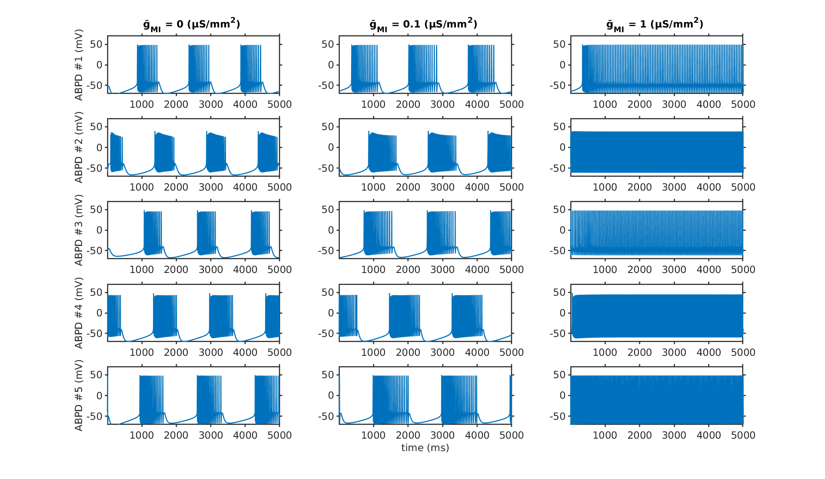
The models were taken directly from the 2004 Nature Neuroscience paper.

Citations
Abbott, L. F., and Gwendal LeMasson. 1993. “Analysis of Neuron Models with Dynamically Regulated Conductances.” Neural Computation 5 (6):823–42. https://doi.org/10.1162/neco.1993.5.6.823.
Blitz, Dawn M., Andrew E. Christie, Melissa J. Coleman, Brian J. Norris, Eve Marder, and Michael P. Nusbaum. 1999. “Different Proctolin Neurons Elicit Distinct Motor Patterns from a Multifunctional Neuronal Network.” Journal of Neuroscience 19 (13):5449–63.
Bucher, Dirk, Astrid A. Prinz, and Eve Marder. 2005. “Animal-to-Animal Variability in Motor Pattern Production in Adults and during Growth.” The Journal of Neuroscience: The Official Journal of the Society for Neuroscience 25 (7):1611–19. https://doi.org/10.1523/JNEUROSCI.3679-04.2005.
Caplan, Jonathan S., Alex H. Williams, and Eve Marder. 2014. “Many Parameter Sets in a Multicompartment Model Oscillator Are Robust to Temperature Perturbations.” Journal of Neuroscience 34 (14):4963–75. https://doi.org/10.1523/JNEUROSCI.0280-14.2014.
Clemens, S., D. Combes, P. Meyrand, and J. Simmers. 1998. “Long-Term Expression of Two Interacting Motor Pattern-Generating Networks in the Stomatogastric System of Freely Behaving Lobster.” Journal of Neurophysiology 79 (3):1396–1408.
Cuntz, Hermann, Friedrich Forstner, Alexander Borst, and Michael Häusser. 2010. “One Rule to Grow Them All: A General Theory of Neuronal Branching and Its Practical Application.” PLoS Computational Biology 6 (8). https://doi.org/10.1371/journal.pcbi.1000877.
Dayan, Peter, and L. F. Abbott. 2001. Theoretical Neuroscience. Computational Neuroscience. Cambridge, Mass.: Massachusetts Institute of Technology Press.
Destexhe, Alain, and Thierry Bal. 2009. Dynamic-Clamp: From Principles to Applications. Springer Science & Business Media.
Dimitrov, Alexander G., Aurel A. Lazar, and Jonathan D. Victor. 2011. “Information Theory in Neuroscience.” Journal of Computational Neuroscience 30 (1):1–5. https://doi.org/10.1007/s10827-011-0314-3.
Drion, Guillaume, Alessio Franci, Julie Dethier, and Rodolphe Sepulchre. 2015. “Dynamic Input Conductances Shape Neuronal Spiking.” ENeuro 2 (1):ENEURO.0031-14.2015. https://doi.org/10.1523/ENEURO.0031-14.2015.
Edelman, Gerald M., and Joseph A. Gally. 2001. “Degeneracy and Complexity in Biological Systems.” Proceedings of the National Academy of Sciences 98 (24):13763–68. https://doi.org/10.1073/pnas.231499798.
Eisen, J. S., and E. Marder. 1982. “Mechanisms Underlying Pattern Generation in Lobster Stomatogastric Ganglion as Determined by Selective Inactivation of Identified Neurons. III. Synaptic Connections of Electrically Coupled Pyloric Neurons.” Journal of Neurophysiology 48 (6):1392–1415.
Foster, W. R., L. H. Ungar, and J. S. Schwaber. 1993. “Significance of Conductances in Hodgkin-Huxley Models.” Journal of Neurophysiology 70 (6):2502–18.
Goaillard, Jean-Marc, Adam L. Taylor, David J. Schulz, and Eve Marder. 2009. “Functional Consequences of Animal-to-Animal Variation in Circuit Parameters.” Nature Neuroscience 12 (11):nn.2404. https://doi.org/10.1038/nn.2404.
Goldman, Mark S., Jorge Golowasch, Eve Marder, and L. F. Abbott. 2001. “Global Structure, Robustness, and Modulation of Neuronal Models.” Journal of Neuroscience 21 (14):5229–38.
Golowasch, J., and E. Marder. 1992a. “Ionic Currents of the Lateral Pyloric Neuron of the Stomatogastric Ganglion of the Crab.” Journal of Neurophysiology 67 (2):318–31.
———. 1992b. “Proctolin Activates an Inward Current Whose Voltage Dependence Is Modified by Extracellular Ca2+.” The Journal of Neuroscience: The Official Journal of the Society for Neuroscience 12 (3):810–17.
Golowasch, Jorge, Mark S. Goldman, L. F. Abbott, and Eve Marder. 2002. “Failure of Averaging in the Construction of a Conductance-Based Neuron Model.” Journal of Neurophysiology 87 (2):1129–31.
Golowasch, Jorge Pablo. 1991. “Characterization of a Stomatogastric Ganglion Neuron. A Biophysical and a Mathematical Description.” Ph.D., United States -- Massachusetts: Brandeis University. https://search.proquest.com/docview/303946944/abstract/E6B53DD28B7A41C6PQ/1.
Gorelik, Gennady. 2002. “Bremermann’s Limit and CGH-Physics.” Center for Philosopy and History of Science, Boston University. https://arxiv.org/vc/arxiv/papers/0910/0910.3424v2.pdf.
Guckenheimer, John, Shay Gueron, and Ronald M. Harris-Warrick. 1993. “Mapping the Dynamics of a Bursting Neuron.” Philosophical Transactions: Biological Sciences 341 (1298):345–59.
Haddad, Sara A., and Eve Marder. 2017. “Circuit Robustness to Temperature Perturbation Is Altered by Neuromodulators.” BioRxiv, August, 178764. https://doi.org/10.1101/178764.
Hamood, Albert W., and Eve Marder. 2015. “Consequences of Acute and Long-Term Removal of Neuromodulatory Input on the Episodic Gastric Rhythm of the Crab Cancer Borealis.” Journal of Neurophysiology 114 (3):1677–92. https://doi.org/10.1152/jn.00536.2015.
Harris-Warrick, Ronald M., Eve Marder, Allen Selverston, and Maurice Moulins. 1992. Dynamic Biological Networks: The Stomatogastric Nervous System. MIT Press.
Hartline, Daniel K. 1979. “Pattern Generation in the Lobster (Panulirus) Stomatogastric Ganglion.” Biological Cybernetics 33 (4):223–36. https://doi.org/10.1007/BF00337411.
Hille, Bertil. 2001. Ion Channels of Excitable Membranes. 3rd ed. Sunderland, MA 01375: Sinauer Associates Inc.
Hod, Shahar. 2015. “Bekenstein’s Generalized Second Law of Thermodynamics: The Role of the Hoop Conjecture.” The Hassadah Institute, Emeq Hefer, Israel.
Hodgkin, A. L., and A. F. Huxley. 1952. “The Components of Membrane Conductance in the Giant Axon of Loligo.” The Journal of Physiology 116 (4):473–96.
Hooper, S. L., and E. Marder. 1987. “Modulation of the Lobster Pyloric Rhythm by the Peptide Proctolin.” The Journal of Neuroscience: The Official Journal of the Society for Neuroscience 7 (7):2097–2112.
Hooper, Scott L. 1997. “Phase Maintenance in the Pyloric Pattern of the Lobster (Panulirus Interruptus) Stomatogastric Ganglion.” Journal of Computational Neuroscience 4 (3):191–205. https://doi.org/10.1023/A:1008822218061.
Johnson, B. R., and R. M. Harris-Warrick. 1997. “Amine Modulation of Glutamate Responses from Pyloric Motor Neurons in Lobster Stomatogastric Ganglion.” Journal of Neurophysiology 78 (6):3210–21.
Juurlink, Bernhard H. J., Patrick H. Krone, William M. Kulyk, Valerie M. K. Verge, and J. Ronald Doucette. 2012. Neural Cell Specification: Molecular Mechanisms and Neurotherapeutic Implications. Springer Science & Business Media.
Kaczmarek, Leonard K., and Irwin B. Levitan. 1987. Neuromodulation: The Biochemical Control of Neuronal Excitability. Oxford University Press.
Kandel, Eric R. 2013. Principles of Neural Science. 5th ed. New York: McGraw-Hill Medical.
Kitano, Hiroaki. 2004. “Biological Robustness.” Nature Reviews Genetics 5 (11):826. https://doi.org/10.1038/nrg1471.
LeMasson, Gwendal, Eve Marder, and L. F. Abbott. 1993. “Activity-Dependent Regulation of Conductances in Model Neurons.” Science; Washington 259 (5103):1915.
Liu, Z., J. Golowasch, E. Marder, and L. F. Abbott. 1998. “A Model Neuron with Activity-Dependent Conductances Regulated by Multiple Calcium Sensors.” The Journal of Neuroscience: The Official Journal of the Society for Neuroscience 18 (7):2309–20.
Lockery, S. R., and N. C. Spitzer. 1992. “Reconstruction of Action Potential Development from Whole-Cell Currents of Differentiating Spinal Neurons.” Journal of Neuroscience 12 (6):2268–87.
Loeb, Gerald E. 2012. “Optimal Isn’t Good Enough.” Biological Cybernetics 106 (11–12):757–65. https://doi.org/10.1007/s00422-012-0514-6.
Mainen, Z. F., and T. J. Sejnowski. 1996. “Influence of Dendritic Structure on Firing Pattern in Model Neocortical Neurons.” Nature 382 (6589):363–66. https://doi.org/10.1038/382363a0.
Marder, E., and R. L. Calabrese. 1996. “Principles of Rhythmic Motor Pattern Generation.” Physiological Reviews 76 (3):687–717.
Marder, Eve. 2012. “Neuromodulation of Neuronal Circuits: Back to the Future.” Neuron 76 (1):1–11. https://doi.org/10.1016/j.neuron.2012.09.010.
Marder, Eve, and Dirk Bucher. 2001. “Central Pattern Generators and the Control of Rhythmic Movements.” Current Biology 11 (23):R986–96. https://doi.org/10.1016/S0960-9822(01)00581-4.
———. 2007. “Understanding Circuit Dynamics Using the Stomatogastric Nervous System of Lobsters and Crabs.” Annual Review of Physiology 69 (1):291–316. https://doi.org/10.1146/annurev.physiol.69.031905.161516.
Maynard, D. M. 1972. “Simpler Networks.” Annals of the New York Academy of Sciences 193 (August):59–72.
Medvedev, Georgi S. 2014. “Small-World Networks of Kuramoto Oscillators.” Physica D: Nonlinear Phenomena 266 (January):13–22. https://doi.org/10.1016/j.physd.2013.09.008.
Michael P. Nusbaum, Dawn M. Blitz, and Eve Marder. 2017. “Functional Consequences of Neuropeptide and Small-Molecule Co-Transmission.” Nature Reviews Neuroscience 18 (7):389–403. https://doi.org/10.1038/nrn.2017.56.
Mizrahi, Adi, Patsy S. Dickinson, Peter Kloppenburg, Valerie Fénelon, Deborah J. Baro, Ronald M. Harris-Warrick, Pierre Meyrand, and John Simmers. 2001. “Long-Term Maintenance of Channel Distribution in a Central Pattern Generator Neuron by Neuromodulatory Inputs Revealed by Decentralization in Organ Culture.” Journal of Neuroscience 21 (18):7331–39.
Nusbaum, M. P., D. M. Blitz, A. M. Swensen, D. Wood, and E. Marder. 2001. “The Roles of Co-Transmission in Neural Network Modulation.” Trends in Neurosciences 24 (3):146–54.
Nusbaum, Michael P., and Mark P. Beenhakker. 2002. “A Small-Systems Approach to Motor Pattern Generation.” Nature 417 (6886):417343a. https://doi.org/10.1038/417343a.
Otopalik, Adriane G., Marie L. Goeritz, Alexander C. Sutton, Ted Brookings, Cosmo Guerini, and Eve Marder. 2017. “Sloppy Morphological Tuning in Identified Neurons of the Crustacean Stomatogastric Ganglion.” ELife 6 (February):e22352. https://doi.org/10.7554/eLife.22352.
Prinz, Astrid A. 2010. “Computational Approaches to Neuronal Network Analysis.” Philosophical Transactions of the Royal Society B: Biological Sciences 365 (1551):2397–2405. https://doi.org/10.1098/rstb.2010.0029.
Prinz, Astrid A., Cyrus P. Billimoria, and Eve Marder. 2003. “Alternative to Hand-Tuning Conductance-Based Models: Construction and Analysis of Databases of Model Neurons.” Journal of Neurophysiology 90 (6):3998–4015. https://doi.org/10.1152/jn.00641.2003.
Prinz, Astrid A., Dirk Bucher, and Eve Marder. 2004. “Similar Network Activity from Disparate Circuit Parameters.” Nature Neuroscience 7 (12):1345–52. https://doi.org/10.1038/nn1352.
Rezer, Elizabeth, and Maurice Moulins. 1983. “Expression of the Crustacean Pyloric Pattern Generator in the Intact Animal.” Journal of Comparative Physiology 153 (1):17–28. https://doi.org/10.1007/BF00610338.
Rinzel, J. 1987. “A Formal Classification of Bursting Mechanisms in Excitable Systems.” In Mathematical Topics in Population Biology, Morphogenesis and Neurosciences, 267–81. Lecture Notes in Biomathematics. Springer, Berlin, Heidelberg. https://doi.org/10.1007/978-3-642-93360-8_26.
Schulz, David J., Jean-Marc Goaillard, and Eve Marder. 2006. “Variable Channel Expression in Identified Single and Electrically Coupled Neurons in Different Animals.” Nature Neuroscience 9 (3):356–62. https://doi.org/10.1038/nn1639.
Selverston, Allen, and Maurice Moulins, eds. 1987. The Crustacean Stomatogastric System. //www.springer.com/us/book/9783642715181.
Sharp, A. A., M. B. O’Neil, L. F. Abbott, and E. Marder. 1993. “Dynamic Clamp: Computer-Generated Conductances in Real Neurons.” Journal of Neurophysiology 69 (3):992–95.
Soofi, Wafa, Marie L. Goeritz, Tilman J. Kispersky, Astrid A. Prinz, Eve Marder, and Wolfgang Stein. 2014. “Phase Maintenance in a Rhythmic Motor Pattern during Temperature Changes in Vivo.” Journal of Neurophysiology 111 (12):2603–13. https://doi.org/10.1152/jn.00906.2013.
Soto-Treviño, Cristina, Pascale Rabbah, Eve Marder, and Farzan Nadim. 2005. “Computational Model of Electrically Coupled, Intrinsically Distinct Pacemaker Neurons.” Journal of Neurophysiology 94 (1):590–604. https://doi.org/10.1152/jn.00013.2005.
Stelling, Jörg, Uwe Sauer, Zoltan Szallasi, Francis J. Doyle, and John Doyle. 2004. “Robustness of Cellular Functions.” Cell 118 (6):675–85. https://doi.org/10.1016/j.cell.2004.09.008.
Stemmler, Martin, and Christof Koch. 1999. “How Voltage-Dependent Conductances Can Adapt to Maximize the Information Encoded by Neuronal Firing Rate.” Nature Neuroscience 2 (6):521–27. https://doi.org/10.1038/9173.
Stiefel, Klaus M., and Terrence J. Sejnowski. 2007. “Mapping Function onto Neuronal Morphology.” Journal of Neurophysiology 98 (1):513–26. https://doi.org/10.1152/jn.00865.2006.
Strogatz, Steven. 2003. Sync: The Emerging Science of Spontaneous Order. Hyperion Books.
Swensen, A. M., and E. Marder. 2000. “Multiple Peptides Converge to Activate the Same Voltage-Dependent Current in a Central Pattern-Generating Circuit.” The Journal of Neuroscience: The Official Journal of the Society for Neuroscience 20 (18):6752–59.
———. 2001. “Modulators with Convergent Cellular Actions Elicit Distinct Circuit Outputs.” The Journal of Neuroscience: The Official Journal of the Society for Neuroscience 21 (11):4050–58.
Tononi, Giulio, Olaf Sporns, and Gerald M. Edelman. 1999. “Measures of Degeneracy and Redundancy in Biological Networks.” Proceedings of the National Academy of Sciences 96 (6):3257–62. https://doi.org/10.1073/pnas.96.6.3257.
Turrigiano, G., G. LeMasson, and E. Marder. 1995. “Selective Regulation of Current Densities Underlies Spontaneous Changes in the Activity of Cultured Neurons.” The Journal of Neuroscience: The Official Journal of the Society for Neuroscience 15 (5 Pt 1):3640–52.
Whitacre, James, and Axel Bender. 2010. “Degeneracy: A Design Principle for Achieving Robustness and Evolvability.” Journal of Theoretical Biology 263 (1):143–53. https://doi.org/10.1016/j.jtbi.2009.11.008.

